Lewiston Lake Living
Twin Lakes Property Owners Association
“making a difference in the life of our lakes and our community”
March, 2024

President’s Letter  Your TLPOA Board of Directors closely follows the workings of the Michigan Lakes and Streams Association (MLSA). The MLSA is a state-wide, non-profit organization dedicated to the preservation and protection of Michigan’s vast treasure of inland lakes and streams.  Valuable information regarding new laws and regulations, water quality concerns, invasive species, and many other factors that affect our lake living experience are discussed within this organization.  The MLSA also allows lake associations such as ours to collaborate with other lake associations through the sharing of ideas and experiences that can hopefully benefit all.  The MLSA is active in lobbying our Michigan legislature to carry out its mission. In January, the MLSA published the below list of its current legislative priorities:  - Regulation of watercraft operating in wake sport mode.  - State-wide septic code as proposed by House Bills 4479 and 4480 and Senate Bills 299 and 300.  - All the legislative recommendations for inland lakes/streams in the joint agency Michigan 2022 Invasive Report.  - No state-wide preemption of local control of short-term rentals.  - No state-wide preemption of local control of mining site development that adversely impacts lakes and streams.  - Tax rebate incentives for new installation of natural shorelines; and partial tax incentives for riparian property owners who have installed a natural shoreline within the last 20 years.  You may not agree with all of these priorities, but our TLPOA organization will strive to keep our membership well-informed as new laws and regulations come into play that may affect you.  But what is your major issue or concern regarding East and West Twin? We would love to hear from you. Just drop us a note at our current email address:  twinlakeslewiston@gmail.com  Looking forward to another enjoyable season on our beautiful lakes.  Tom Conquest | TWIN LAKES PROPERTY OWNERS ASSOCIATION  OFFICERS  President  Tom Conquest  Vice President  Pat Kish  Treasurer  Colin Gibbings  Secretary  Bill Siegrist  Board Members  Alex Goodall  John Jackson  Tim Manganello  Tom Page  Pete Stephens  Judd Wellard  Consultant  Bonnie Page  Website  www.tlpoalewistonmi.com  Join us on Facebook!  Twin Lakes POA, Lewiston MI  Mailing Address  TLPOA, P.O. Box 807,  Lewiston, MI 49756  If you have comments or suggestions, please contact us:  twinlakeslewiston@gmail.com  Thanks to all those who contributed to this issue.  Pat Kish, Editor

Twin Lakes Property Owners Association
Statement of Activities for January 1 to December 31, 2023
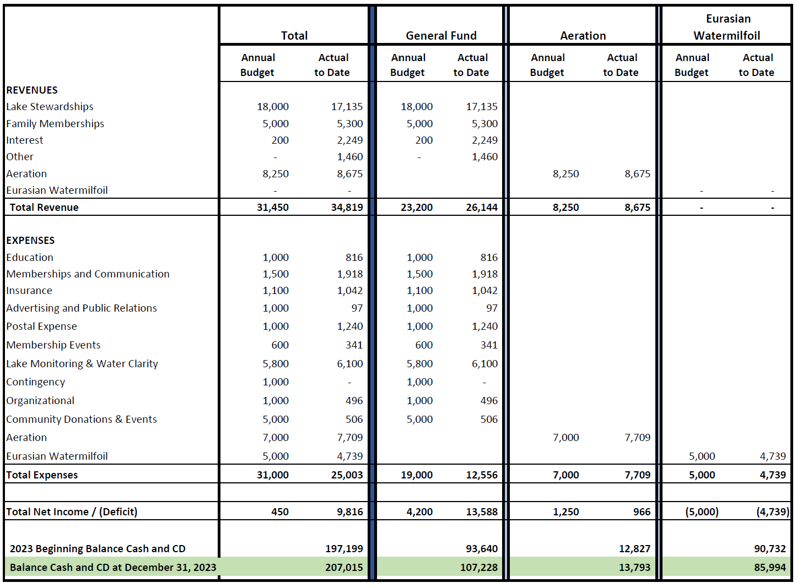

In and around the lakes…
- Donations for Independence Day fireworks are being collected at the Twin Lakes Marina. Fireworks will soar again over East Twin Lake on July 3 (rain date of July 4). Let’s keep this tradition booming by pitching in to help marina proprietors Bob and Mary Walter with the costs of this event.
- The 63rd Annual MLSA Conference is scheduled for Friday, April 26 and Saturday, April 27, 2024 at the new VanDyk Mortgage Convention Center in Muskegon, MI. Discussion topics include invasive species, septic regulations, and association best practices. Last year TLPOA President Tom Conquest represented our association and he plans to do so again this year. For more information, please visit https://mymlsa.org/mlsa-events/annual-conference-2024/.
- The TLPOA is looking for members to host 2024 social events such as the Heart of the Summer Party, held in June or July, or the Wine and Cheese Party, held in late summer or fall. If you would like to volunteer, please send an email to twinlakeslewiston@gmail.com. Hosts receive a stipend to defray expenses.
- Eurasian watermilfoil (EWM) contract signed with PLM Lake & Land Management for 2024 season.
- We were going to include an item regarding ice safety on the lakes at this time of year, but, well…there would have to be ice on the lakes.

For more information regarding the activities of the TLPOA Board, please read the Board Minutes posted on the TLPOA website at https://www.tlpoalewistonmi.com/meeting-minutes. Board meetings are open to the public. If you would like to learn more about serving on the TLPOA Board or volunteer to work on specific projects such social events or water testing, please send an email to twinlakeslewiston@gmail.com.

Additional Water Quality Testing Planned for 2024
Your TLPOA has participated in the Cooperative Lakes Monitoring Program (CLMP) program for over 30 years providing us with yearly status reports on the water quality of our East and West Twin Lakes. While the CLMP provides valuable information regarding our lakes’ water quality, it is somewhat limited. Water samples are only taken in one location of each lake and root causes of water quality trends over time are not easily identified.

To better supplement our CLMP data, the TLPOA Board of Directors, led by Board Member John Jackson, has elected to conduct additional water quality testing in 2024. The Spicer Group, an engineering environment organization, has been awarded a $29,000 contract to conduct detailed water quality testing on both East and West Twin Lakes in 2024. Three sets of samples will be collected this coming season at eight specific locations, five on East Twin and three on West Twin.

Each location will be tested for the following:

- Total Nitrogen
- Soluble Reactive Phosphorus
- Total Phosphorus
- Total Suspended Solids
- Total Chloride
- Chlorophyll-a

Water testing will be performed by two accredited laboratory facilities. Test results will hopefully provide us the information necessary to make future decisions which may include corrective actions, further testing, etc.

Save These Dates
Event | Date | Time | Location
TLPOA Membership Meeting | Saturday,  May 25 | 8:30 a.m. Welcome with donuts and coffee  9:00 a.m. Meeting | Lewiston Elementary School
Fireworks | July 3 | Dusk | East Twin Lake
Boat Parades | July 4 | 5:30 p.m. | East Twin: Island  West Twin: Eagle Point
TLPOA Membership Meeting | Saturday,  August 24 | 8:30 a.m. Welcome with donuts and coffee  9:00 a.m. Meeting | Lewiston Elementary School

Canada Goose Population Control
As you are probably aware the Canada Goose population has exploded nationwide, in Michigan, and of most concern to us, on East and West Twin Lakes. The Michigan DNR estimates that there are now over 300,000 Canada geese in Michigan, up from nearly being extinct in the 1940’s. Some estimates are that there are up to 150 nesting Canada geese on East Twin Lake alone.

These geese are becoming a major problem. Not only do they foul your lawn when they decide to feed on it, but they can present a serious health hazard, especially to small children. Canada goose defecate up to 2 lbs. of feces every day. That feces contains pathogenic protozoa and bacteria. Direct contact by children can occur when playing in the yard or on the beach or by ingesting lake water that has been contaminated by goose feces.

The other issue regarding our lakes is the amount of phosphorus that geese can defecate into the water. The feces from a single goose can leave up to a half pound of phosphorus per year. With an estimated 150 geese on East Twin alone, that is the equivalent of 75 lbs. of phosphorus being added to the lake each year.

Phosphorus can be detrimental to the lake because it can accelerate plant growth and algae blooms. One pound of phosphorus can support 500 pounds of algae. So the estimated goose population on East Twin is adding up to 37,500 lbs. of potential algae growth to the lake.

This is supported by our own studies of East Twin Lake. TLPOA takes phosphorus readings every summer on both East and West Twin Lakes. While West Twin’s phosphorus readings have remained consistent, East Twin’s readings have shown a slight increase. While there can be a couple of reasons for the increase, the exploding Canada goose population is certainly one of them.

Fortunately, there is something that we can do. The DNR has a program to help control Canada goose populations. It consists of both an egg/nest destruction element and a round up/relocation element. However, the Michigan DNR has not allowed the roundup portion for the past few years, including this year.

In light of this, the TLPOA has applied to the DNR for the egg/nest destruction program for 2024. Both Albert Township and Charlton Township have passed resolutions in support of this program. If approved by the DNR, we will hire a firm called Goose Busters to conduct the program. It consists of Goose Busters locating the goose nests during the nesting season, usually late March to early April, removing the eggs, and destroying the nests. No live geese are harmed during the process.

This is a multi-year program that will most likely be necessary to continue for several years. It probably won’t reduce the goose population much in 2024. The idea is to make our lakes an inhospitable place for the geese to nest. After a few years of unsuccessful nesting, the geese will be motivated to find different lakes to build their nests. Typically, they move further north.

When the program is implemented, Goose Busters will look around our lakes in order to find the nests. This may require them to have access to your property. While the DNR permit will allow us to hire Goose Busters to find and destroy the goose eggs and nests, it does not give explicit permission to access your property. However, they will knock on your door before they look around your property. So, if you do not want Goose Busters to check your property for goose nests, you must let them know by putting a sign on your door to that effect.

They will be conducting their search in late March or early April. Hopefully you and everyone else on East and West Twin Lakes will cooperate and we can begin to reduce the population of Canada geese.
If you have any questions, please feel free to email Tom Page at umsu1@sbcglobal.net. | 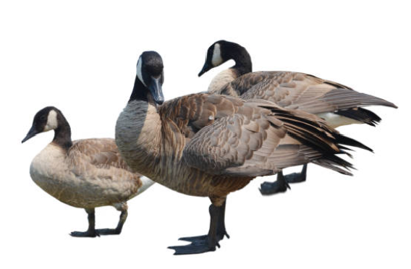

>>> Please check your newsletter mailing label for your current membership status. <<<

TLPOA Membership Dues and Donations
New Member Renewal
Send my newsletters (except during November’s membership drive) by email only.

Member(s) Name(s) ___________________________________________________________________________

Email Address(es) _____________________________________________________________________________

Primary Mailing Address_________________________________________________________________________

City __________________________________________________State__________________ZIP_____________

Lake Address __________________________________________________________________________________

Telephone ( ) __________________________ East Twin Lake West Twin Lake

Membership Dues and Donations

 | Membership Dues or  Suggested Contribution Amounts |  | My Lake Contribution
Membership Dues  Lake Stewardship provides additional funding for special projects to study and maintain a healthy lake ecology and benefit the lake community. | $150 Lake Stewardship  or  $35 Basic Family Membership |  | $
Aeration Suggested Contribution  Your contribution will allow the TLPOA to maintain the aeration system on East Twin Lake, including replacing parts as needed, and paying for electricity. Suggested contribution rates based on lake frontage owned are shown at right. We welcome all levels of contribution! | Lakefront Owners  Less than 75 ft. of lake frontage  75 to 125 ft. of lake frontage  More than 125 ft. of lake frontage  Shared Access | $50  $75  $100  $25 | $
Eurasian Watermilfoil Treatment Generous contributions from our membership along with grants from Montmorency County have allowed the TLPOA to respond quickly to control EWM and have covered the anticipated costs of surveying and treating infested areas. | We are currently funded at a sufficient level to meet current needs  and have suspended our  requests for funding.  Thank you!
 | MY TOTAL LAKE CONTRIBUTION |  | $

THANK YOU FOR YOUR GENEROUS SUPPORT! PLEASE JOIN OR RENEW TODAY!
The TLPOA is a 501(c)(3) public charity and your contribution may be deductible if you itemize your deductions on your tax return. Consult your tax adviser for details.
New! Two ways to pay:
- with a check payable to TLPOA and mailed to P.O. Box 807, Lewiston, MI 49756 or
- online with a credit card at www.tlpoalewistonmi.com/.

New! Now you can pay your TLPOA dues and donate to the TLPOA online!
Members of the TLPOA Board have been working with Carrie’s Creations, a website designer and host, to make the TLPOA website better serve its members’ needs and make it more convenient to make payments. New and renewing members can now use the following link to pay their dues and make donations via PayPal:
www.tlpoalewistonmi.com/ and click on
Renew/Join
Join Today!

Rather not pay online? New and renewing members may continue to print and fill in the membership form available on Page 7 of this newsletter or on our website and mail a check to TLPOA, P. O. Box 807, Lewiston, MI 49756.

We welcome your feedback. If you have any questions or concerns, please send an email to twinlakeslewiston@gmail.com.

Twin Lakes Property Owners Association
P.O. Box 807
Lewiston, MI 49756

***** BE SURE TO CHECK YOUR MAILING LABEL. *****

DO YOU NEED TO RENEW YOUR TLPOA MEMBERSHIP? RENEW TODAY!
PLEASE HELP KEEP OUR LAKES HEALTHY!

