As part of a long-term Walleye monitoring project, Michigan DNR’s Tribal Coordination Unit placed temperature loggers and took temperature and dissolved oxygen profiles in East and West Twin Lakes between March and November 2024. A fall walleye index survey was also conducted in September 2024 in both lakes to evaluate stocking success and natural Walleye recruitment. These efforts will continue for the next 10-20 years in addition to periodic walleye population estimates and fish community surveys. East and West Twin Lakes are currently scheduled for these comprehensive fisheries surveys in spring and early summer 2026.
The water temperatures in East and West Twin Lakes from March to November 2024 were very similar, which was expected for lakes so close together. The daily average temperature in West Twin Lake was slightly cooler by 1-2^{O}F at a few over the open water season, but the overall trends were nearly identical and were comparable to the five other long-term monitoring lakes. The range of water temperatures across the season was 32 – 85 F for both lakes.
Similarly, temperature and dissolved oxygen profiles taken at the deepest point in each lake in spring (March), summer (August), and fall (November) indicated similar trends in dissolved oxygen levels and temperature during spring and summer, with a slight decline in temperature and rapid decline in dissolved oxygen beginning at 16-17 ft in the summer profiles (Figures 2 and 3). A decrease in dissolved oxygen is expected in summer when lakes are most likely to be stratified, though both lakes only exhibited mild thermal stratification in August. The lack of significant temperature stratification is due to the shallow depth of both East and West Twin Lakes. The fall profiles also had the same trends for both lakes, which is expected after the lake mixes in fall and water temperature and dissolved oxygen are typically uniform throughout the water column (Figures 2 and 3).
Secchi depth measurements were recorded on each lake when temperature and dissolved oxygen profiles were taken, except for the May 2023 profiles (Table 1). The depths observed in 2024 by Michigan DNR were very similar to those reported by volunteers from the Cooperative Lakes Monitoring Program and measured by DNR in previous years. Secchi depth measurements in West Twin Lake were similar for 2023 and 2024, but in East Twin Lake Secchi depth was the lowest since 2022 in August 2024.
Fall Walleye index survey results were compared to previous survey results for East and West Twin Lakes. These surveys are conducted at night using an electrofishing boat to survey the entire shoreline and are intended to target Age-0 Walleye, but adult Walleye are sometimes captured. All Walleye caught are measured and a dorsal fin clip is taken for aging before the fish are released. In East Twin Lake, no Age-0 Walleye were captured but there were no walleye stocked in 2024 (Table 2). A higher catch rate in stocked years compared to non-stocked years would be expected in both East and West Twin Lakes because they are known to be reliant on stocking to produce a fishery. In West Twin Lake, 60 Age-0 Walleye were captured (21.9 Age-0 Walleye per mile) which is comparable to previous years. West Twin Lake has typically had lower Age-0 Walleye catch rates than East Twin Lake even though stocking rates are relatively similar between the two systems
Walleye stocked into West Twin Lake in spring 2024 were not marked with oxytetracycline (OTC), so a sample could not be taken to confirm the percentage of Age-0 fish that were from that stocking event.
Table 1. Secchi depth measurements taken by Michigan DNR (2023, 2024) and by the Cooperative Lakes Monitoring Program (2022-2024) in East and West Twin Lakes, Montmorency County.
 |  | Secchi Depth (ft)
Organization | Month and Year | East Twin Lake | West Twin Lake
Michigan DNR | August 2023 | 10 | 12.5
Michigan DNR | March 2024 | 14 | 21
Michigan DNR | August 2024 | 7 | 10.3
CLMP | May 2022 | 11.5 | 13
CLMP | August 2022 | 8 | 13
CLMP | May 2023 | 11.5 | 16
CLMP | August 2023 | 10.5 | 12
CLMP | August 2024 | 8 | 10.5
Table 2. Summary of fall walleye evaluations of East Twin Lake, Montmorency County. Asterisk (*) indicates a year in which spring fingerling Walleye stocking occurred.
Year | Miles Shocked | Hours Shocked | No. Age-0 Walleye | Catch per Mile | Catch per Hour
2003* | 3.00 | 2.00 | 178 | 59.3 | 89.0
2011* | 1.00 | 1.00 | 74 | 74.0 | 74.0
2015* | 5.51 | 3.08 | 265 | 48.1 | 86.0
2017* | 2.00 | 0.80 | 94 | 47.0 | 117.5
2019* | 4.00 | 2.05 | 219 | 54.8 | 106.8
2023* | 5.23 | 2.08 | 149 | 28.5 | 71.6
2024 | 5.4 | 2.03 | 0 | 0 | 0

Table 3. Summary of fall Walleye evaluations of West Twin Lake, Montmorency County. Asterisk (*) indicates a year in which spring fingerling Walleye stocking occurred.
Year | Miles Shocked | Hours Shocked | No. Age-0 Walleye | Catch per Mile | Catch per Hour
1998* | -- | 1.5 | 5 | -- | 3.3
1999* | -- | 2.0 | 16 | -- | 8
2000* | -- | 1.5 | 12 | -- | 1.3
2001 | -- | 2.3 | 0 | -- | 0
2004* | 3.84 | 2.1 | 43 | 11.2 | 21
2011* | 1.5 | 1.5 | 60 | 40 | 40
2022* | 4.0 | 2.50 | 42 | 10.5 | 16.8
2023 | 6.25 | 2.03 | 0 | 0 | 0
2024 | 6.6 | 2.64 | 58 | 8.8 | 21.9

Figure 1. Average daily water temperatures from March 2024 to October 2024 in East and West Twin Lakes, Montmorency County.

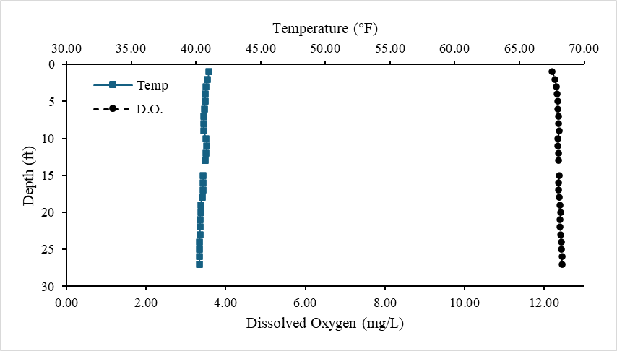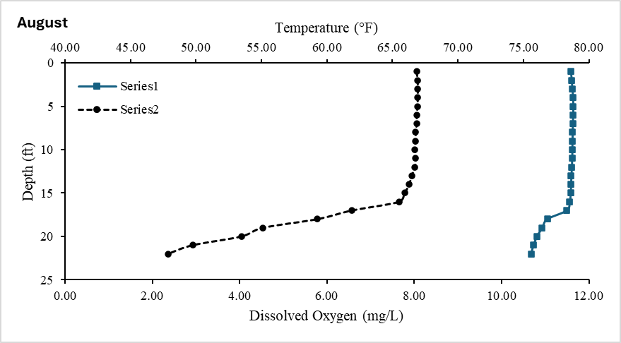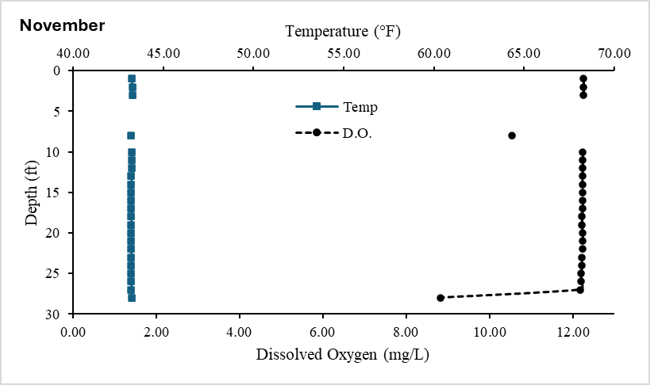
March
Figure 2. Temperature and dissolved oxygen profiles from March (top), August (center), and November (bottom) in East Twin Lake, Montmorency County.
November
August
March
Figure 3. Temperature and dissolved oxygen profiles from March (top), August (center), and October (bottom) in West Twin Lake, Montmorency County.

